DBMS LAB EXPERIMENTS
CSA0501-Database management and systems
Name: K.Tejaswi Department : Btech AI&ML
Regno: 192525407

DDL Commands:
Drop :
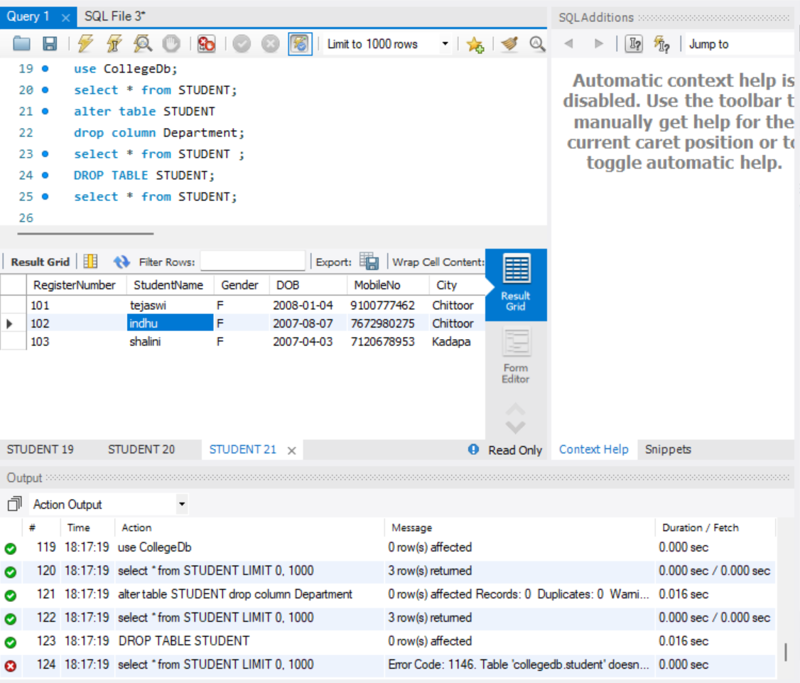

Create:

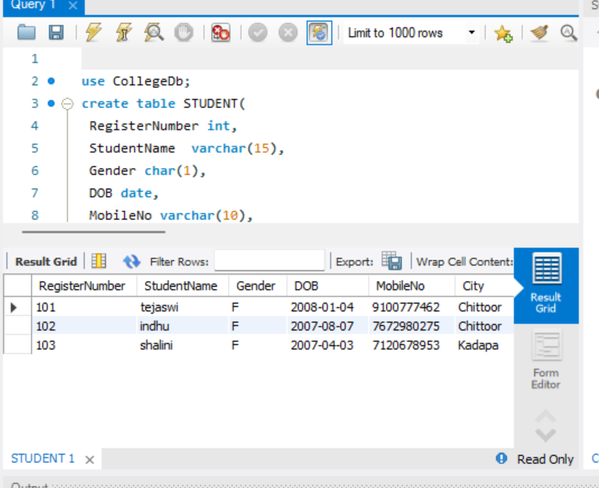

Truncate :

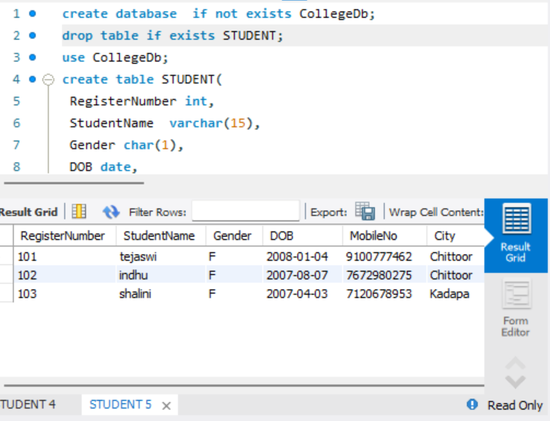

Alter:

